**Recommended Action: Metering Service Availability**

|  |  |  |
| --- | --- | --- |
| Service | RA ID | RA Name |
| [CF Metering](https://jtrack.wdf.sap.corp/browse/SERVICE-367) |  | Metering Service Availability |

**Description**: This alert is raised if the Availability Check for the Service is not responding.

# **Steps to resolve the incident:**

# CF Metering as a service is down

1. Open landscape for which the Alert is received: List of All Landscapes

CF Canary [https://account.int.sap.hana.ondemand.com/cockpit - /home/allaccounts/?datacenter=cf-eu10-canary](https://account.int.sap.hana.ondemand.com/cockpit#/home/allaccounts/?datacenter=cf-eu10-canary)

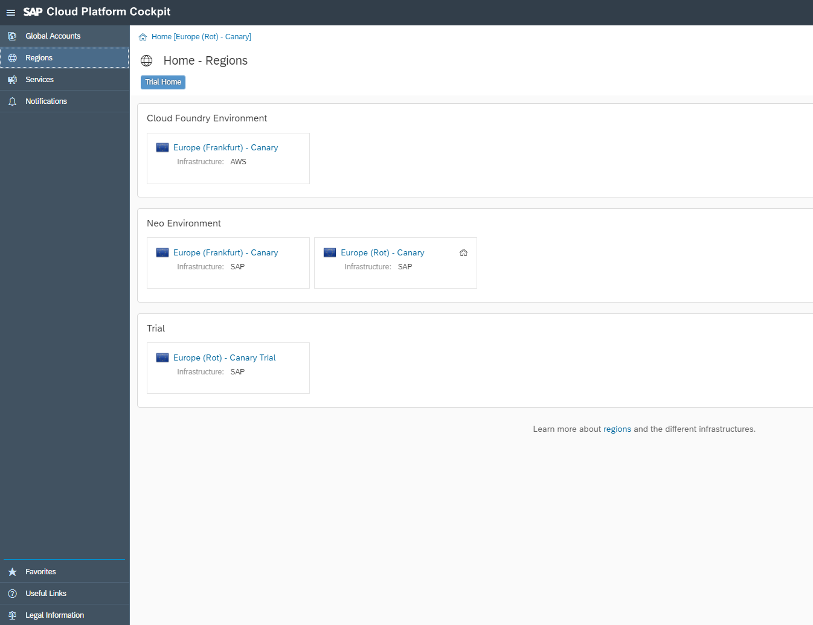

1. Navigate to :

Global Account: platformanalytics

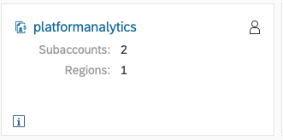

Subaccount : SAP_metering

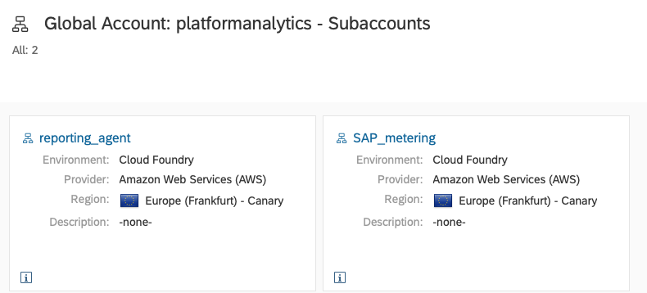

spaces : metering

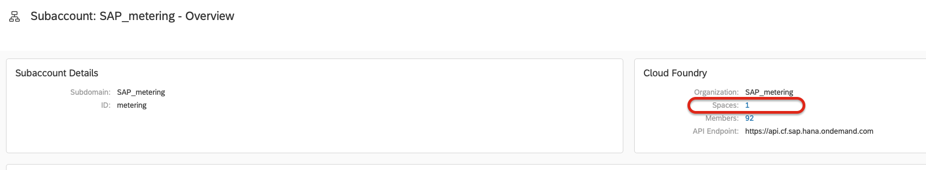

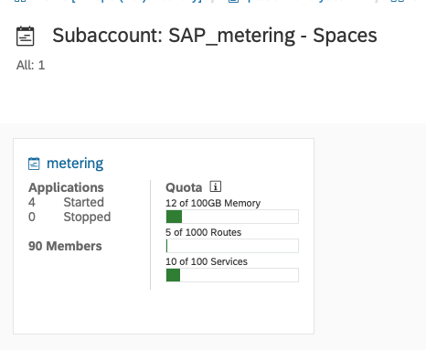

1. Check that the following applications is started:
   1. maas-metering
   2. metering-broker
   3. application-bridge

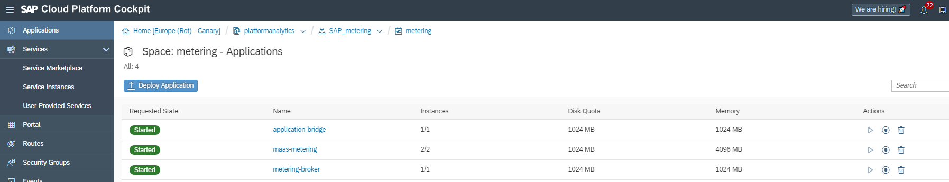

1. Check the state column and if it is stopped go to action and press play (e.g. for abacus-integration-agent)



1. **If the service is not started after step 5**

* Press on the name of the application e.g. maas-metering



* Go to Logs and check if there are errors

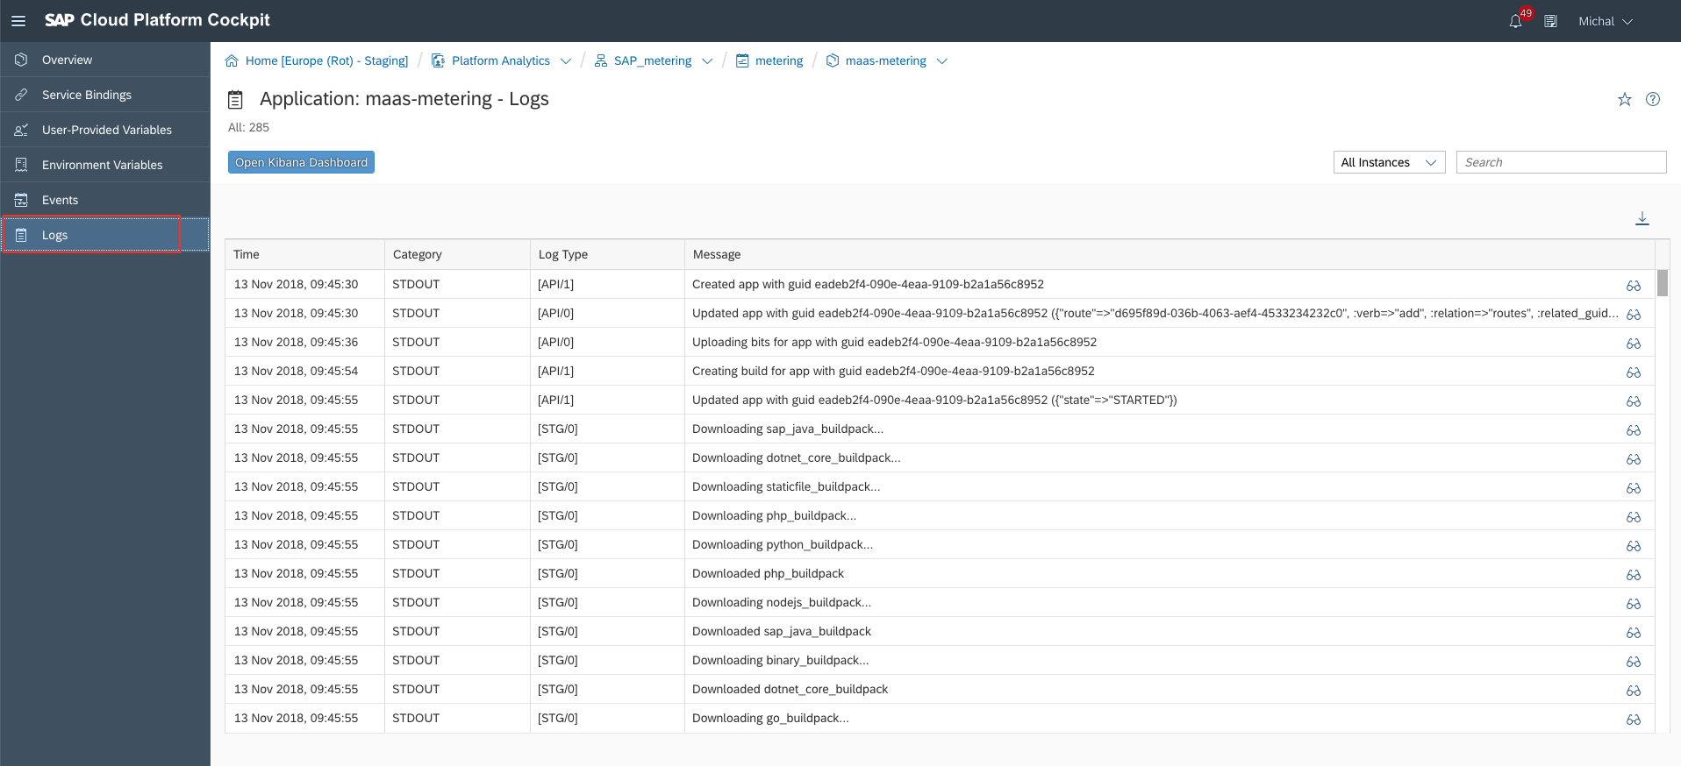

NB: ! In case of identifying an error in the logs, please add the DoD according to the following [WiKi](https://wiki.wdf.sap.corp/wiki/display/CloudEng/DoD+-+CF+Metering+as+a+Service+-+Active+Schedule) to the handover mail!

# **Steps to handover the Incident:**

* Inform [[CE On Duty](https://wiki.wdf.sap.corp/wiki/x/th_Uag)](https://wiki.wdf.sap.corp/wiki/display/EngSrv/30+CE+Engineer+on+Duty) with the relevant details like Landscape and Service name that is impacted.
* Update the SPC with relevant findings while executing the RA

Back to execution of step 2

# CF Landscape Account Cockpit List

|  |  |  |  |  |
| --- | --- | --- | --- | --- |
| **Technical Key** | **Display Name** | **Account Cockpit URL** | **Visibility** | **Provider** |
| cf-eu1 | Europe (Rot) | <https://account.hana.ondemand.com/cockpit#/home/allaccounts/?datacenter=cf-eu1> | Public | SAP |
| cf-us10 | US East (VA) | <https://account.hana.ondemand.com/cockpit#/home/allaccounts/?datacenter=cf-us10> | Public | Amazon |
| cf-eu10 | Europe (Frankfurt) | <https://account.hana.ondemand.com/cockpit#/home/allaccounts/?datacenter=cf-eu10> | Public | Amazon |
| cf-br10 | Brazil (São Paulo) | <https://account.hana.ondemand.com/cockpit#/home/allaccounts/?datacenter=cf-br10> | Public | Amazon |
| cf-jp10 | Japan (Tokyo) | <https://account.hana.ondemand.com/cockpit#/home/allaccounts/?datacenter=cf-jp10> | Public | Amazon |
| cf-ca10 | Canada (Montreal) | <https://account.hana.ondemand.com/cockpit#/home/allaccounts/?datacenter=cf-ca10> | Public | Amazon |
| cf-ap10 | Australia (Sydney) | <https://account.hana.ondemand.com/cockpit#/home/allaccounts/?datacenter=cf-ap10> | Public | Amazon |
| cf-ap11 | Singapore | <https://account.hana.ondemand.com/cockpit#/home/allaccounts/?datacenter=cf-ap11> | Public | Amazon |
| cf-eu10-canary | Europe (Frankfurt) - Canary | <https://account.int.sap.hana.ondemand.com/cockpit#/home/allaccounts/?datacenter=cf-eu10-canary> | Internal | Amazon |
| cf-eu20 | Europe (Netherlands) | <https://account.int.sap.hana.ondemand.com/cockpit#/home/allaccounts/?datacenter=cf-eu10-canary> | Public | Microsoft |
| cf-us30 | US Central (IA) | <https://account.hana.ondemand.com/cockpit#/region/cf-us30/overview> | Public | Google |